SAD TUT WEEK 6
Exercise 1:
Link: https://www.figma.com/proto/4pWNotOvdvuZrrrM9yJQB1/SAD-TUT-6-EX1?node-id=2-10&t=jFAHe7csYKR5cq5s-1
- Login:
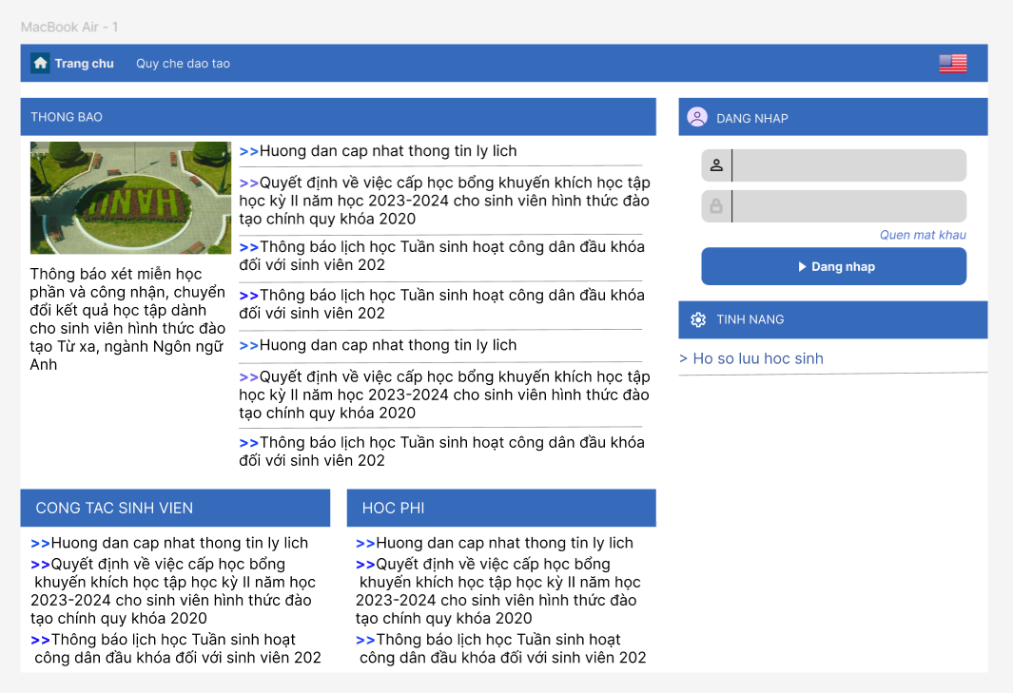

- Profile:
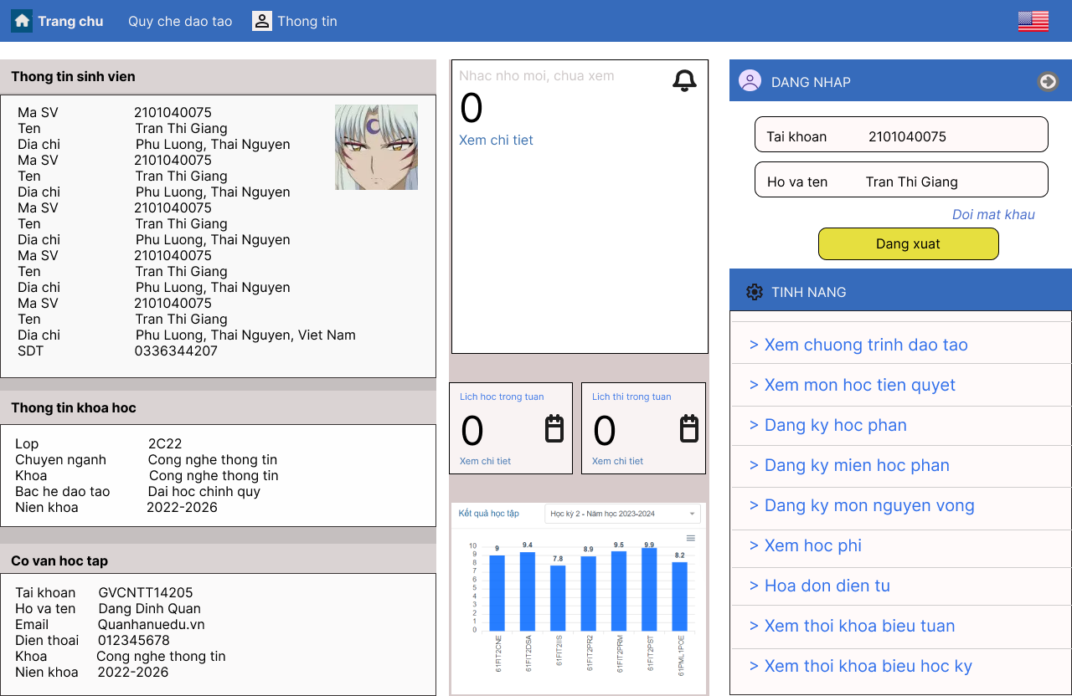

- Tuition fee:
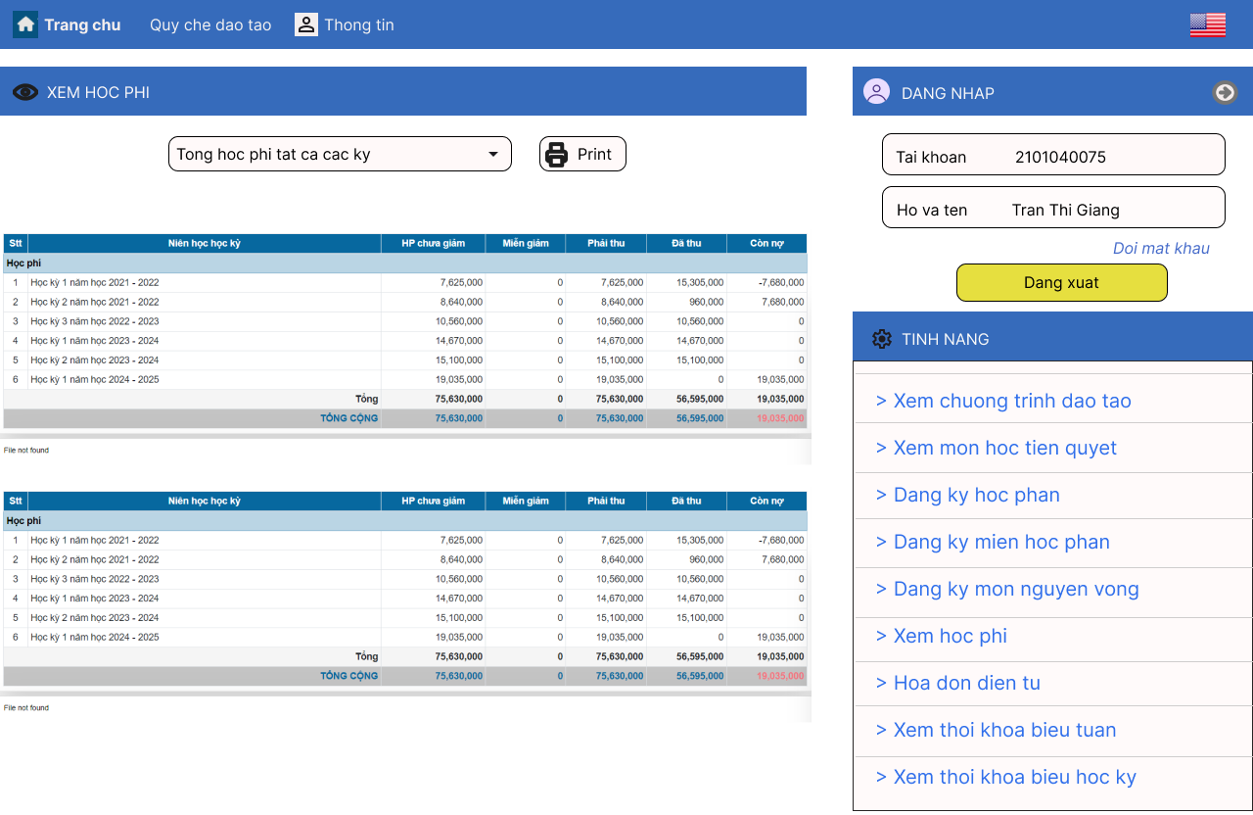
Explaination:
Guidelines has been used and their effect:
- Consistency: The interface maintains a consistent layout, color scheme, and navigation structure across different screens. This helps users quickly understand how to interact with the system.
Effect: Improved learnability and efficiency for users as they can apply knowledge from one screen to another.
- Clear visual hierarchy: Important elements like the main navigation menu, login section, and content areas are visually distinct through use of color, size and placement.
Effect: Helps guide users' attention to key areas and makes the interface more scannable.
- Grouping related information: Information is organized into logical groups, like student details, academic information, and financial information.
Effect: Makes it easier for users to find related pieces of information quickly.
- Feedback: The system provides clear feedback on the user's current state, such as showing the logged-in user's name and ID.
Effect: Helps users understand their current context within the system.
- Accessibility: The interface includes options for changing language (US flag icon visible), which supports accessibility for different user groups.
Effect: Makes the system usable for a wider range of users.
- Progressive disclosure: Complex information (like detailed fee breakdowns) is initially hidden but can be expanded when needed.
Effect: Reduces cognitive load by not overwhelming users with all information at once.
- Familiar metaphors: Uses familiar icons and terms (e.g. home icon, print button) that align with common web conventions.
Effect: Leverages users' existing mental models to make the interface more intuitive.
- Responsive design: The layout appears to adapt to different screen sizes (as evidenced by slight differences between images), suggesting a responsive design approach.
Effect: Ensures usability across different devices and screen sizes.
=> These guidelines work together to create an interface that aims to be user-friendly, efficient, and accessible for students accessing their academic information.

Exercise 2:
Example: Vietnam Airlines Website (www.vietnamairlines.com)
Usability Factors:
Learnability:
Problem:
- Overcrowded homepage with excessive information.
- Key features like booking, check-in, and reservation management are hard to find.
- Scattered and poorly labeled navigation buttons make starting difficult.
Impact:
New users, especially those unfamiliar with technology, struggle to complete basic tasks, wasting time.
Efficiency:
Problem:
- Booking process is lengthy with multiple steps across different pages.
- Slow page load times make it frustrating to search or check in.
Impact: Inefficient design causes delays, frustrates users, and leads many to abandon the booking process midway.
Memorability:
Problem: Inconsistent layout makes it hard for users to remember where features are located.
(Example: Flight booking section varies depending on how it's accessed (homepage vs. separate page).)
Impact: Returning users need to relearn the site, causing unnecessary delays and inefficiency.
Errors:
Problem: Unclear error messages and difficulty in resolving booking issues.
(Example: Vague error messages with no guidance when a search fails.)
Impact: Users become frustrated, abandon the website, or contact customer service, adding to frustration.
Satisfaction:
Problem:
- Users are dissatisfied with slow loading times, poor navigation, and unhelpful error messages.
- Homepage cluttered with irrelevant advertisements and content.
Impact: Users prefer third-party booking platforms for smoother experiences, reducing direct engagement with Vietnam Airlines.
Conclusion:
The Vietnam Airlines website suffers from significant usability issues, including poor learnability, inefficiency, and low user satisfaction. Improving design, speeding up page loads, and offering clearer feedback are essential to enhancing user experience.

